**Please provide me with the following for the Client Letter:**

1. Your ID at Client Site (if known): wei.liu@nscorp.com
2. Copy of Your Badge at Client (if applicable):

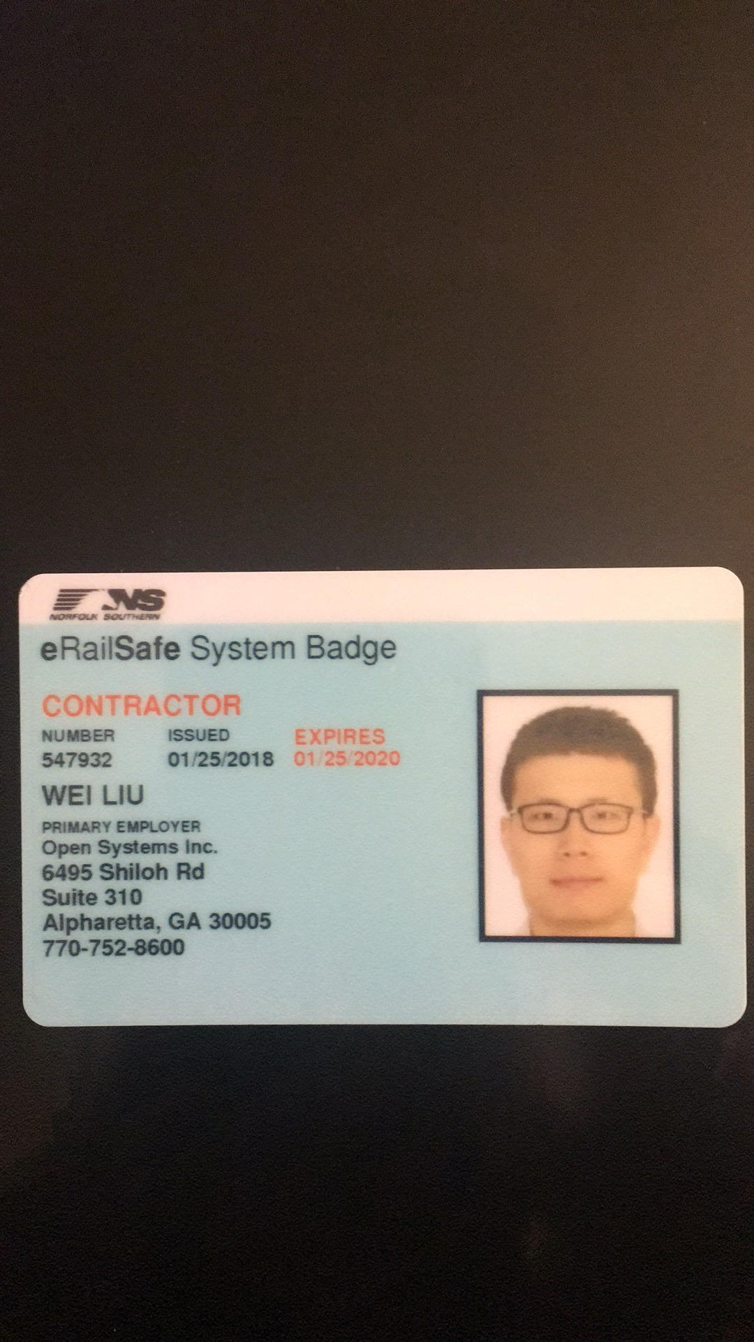

1. Your Full Legal Name: Wei Liu
2. Country of Birth: China
3. Client Name: Norfork Southern Railway
4. Client Work Location Address: 1200 Peachtree St NE, Atlanta, GA, USA, 30309
5. Client Department: Information Technology
6. Project Title (if applicable):
7. Your Title at Client: Data Scientist
8. Please provide the top five main responsibilities for your role. Each responsibility should be kept to a maximum of **two** sentences per item.
9. Collaborate with product management and engineering departments to understand company needs and devise possible solutions
10. Mine and analyze data from big-data databases, perform data cleansing and engineering.
11. Analyze the requirements from business partners, develop custom machine learning models and algorithms to apply to big-data sets.
12. Use predictive models to provide actionable insights to the business partners.
13. Develop A/B testing framework and test model quality, analyze and optimize the model outcomes.
14. Your Current Pay Rate: 45$/h
15. Client Manager Name: Amouie Mabby
16. Client Manager Title: Senior Manager Advanced Analytics
17. Client Manager Email Address: [Mabby.Amouie@nscorp.com](mailto:Mabby.Amouie@nscorp.com)